SIMATS ENGINEERING
ASSESSMENT TOOL 2

COURSE NAME: Database Management Systems
COURSE CODE: CSA0504

COURSE OUTCOME COVERED
CO1: Analyse DBMS architecture, different data models, schema types, and design
ER/EER diagrams, relational schemas for case-based scenarios by identifying
entities and relationships. (BL1, BL2)

- Construct a concept map linking the following terms: DBMS, Schema, Instance, Data Model, ER Diagram, Entity, Attribute, Relationship.

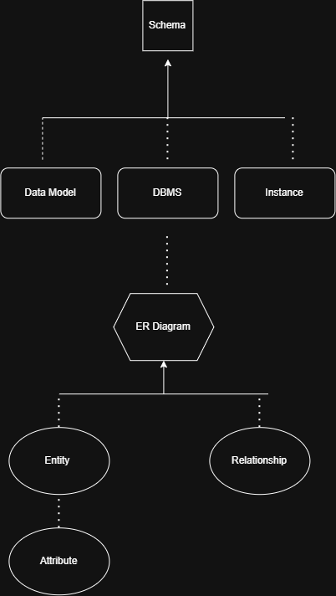

- Create a concept map for the three-level ANSI/SPARC architecture
showing data independence at each level.

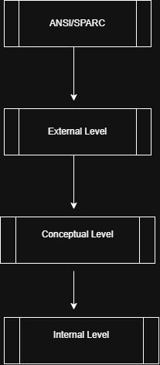

NOTE:
Logical Data Independence (External ↔ Conceptual)
Physical Data Independence (Conceptual ↔ Internal)

- Map the relationship between file-based systems and database systems, highlighting the problems solved by DBMS.

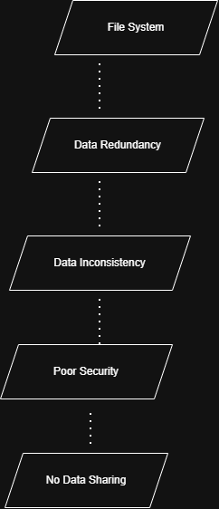

4. Design a concept map for ER diagram components: entity, weak
entity, attribute types, relationship types, and participation
constraints.
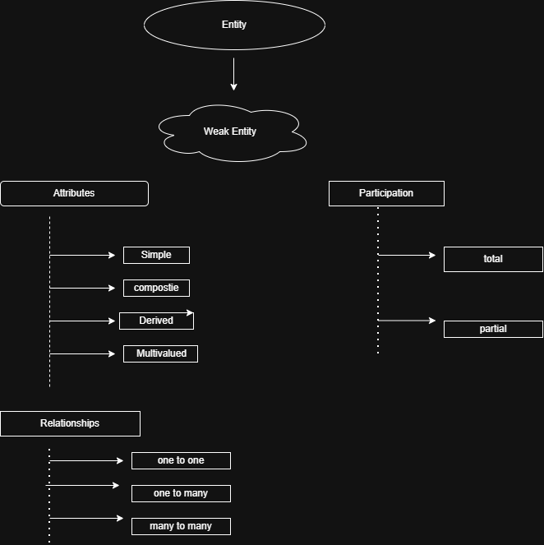

5 Construct a concept map comparing Hierarchical, Network, and
Relational data models with their key properties.
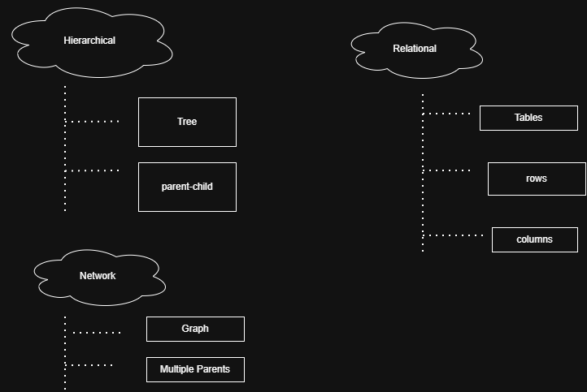

6. Develop a concept map for the EER model showing how it extends
the basic ER model with generalization, specialization, and
aggregation.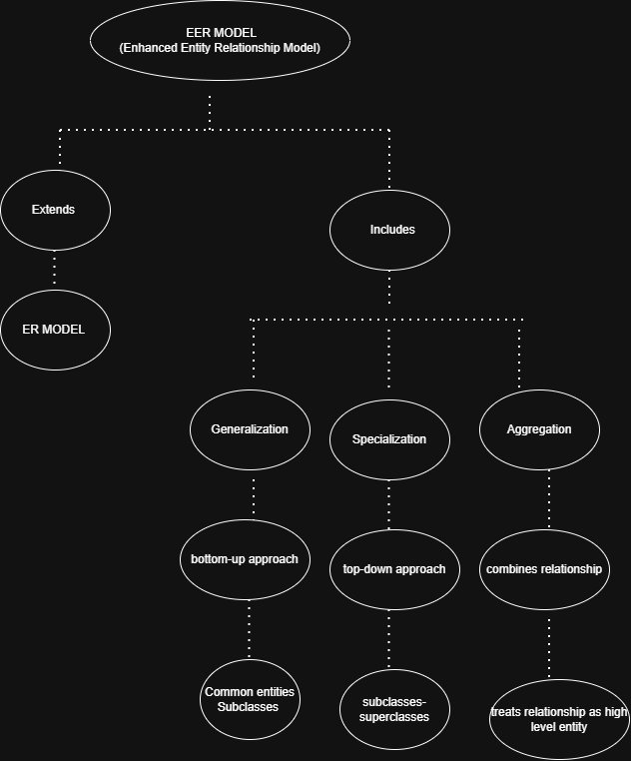

7. Create a visual concept map for the DBMS software architecture,
illustrating the flow from user request to data retrieval.
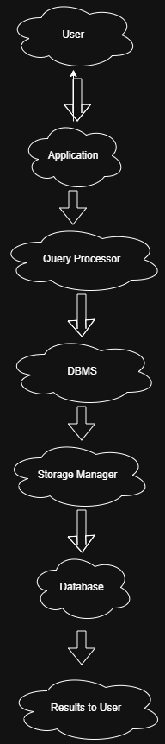

8. Map the data models discussed in CO1 to real-world applications
and explain the suitability of each model.
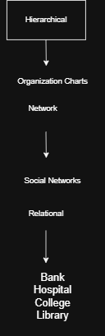

9. Construct a concept map for schemas and instances, showing how
they relate to physical and logical data independence.
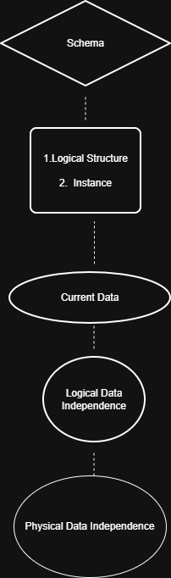

10. Design a concept map for the roles and responsibilities in a DBMS
environment: DBA, End User, Application Developer.
